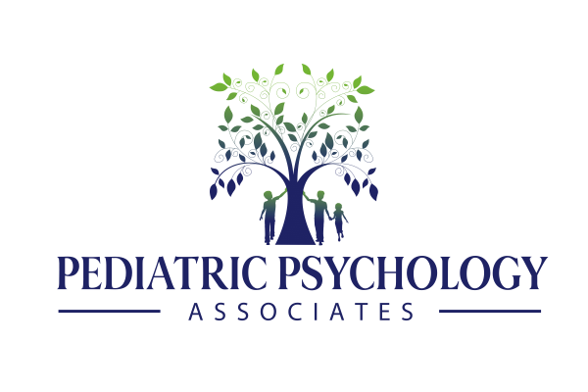

#### **Aventura • Weston • Coral Gables • Coral Springs**

#### **Miami-Dade (305) 936-1002 • Broward (954) 753-1112 www.SouthFloridaTherapists.com**

* Social Thinking Program
* The PEERS Program
* Mindfulness-Based Stress Reduction
* Interpersonal Process Group for Teens
* OCD Support Group
* Eating Disorders Support Group
* Teen Type-1 Diabetes Support Group
* Psychoeducational, Neuropsychological, & Developmental Evaluations
* Gifted/Intelligence Evaluations
* Multi-Disciplinary Developmental Clinic (MDDC)
* Individual & Family Therapy
* Group Therapy Programs
* Anxiety & Obsessive Compulsive Disorder Intensive Outpatient Program (IOP)
* International Services
* Consultations
* Seminars/Workshops
* Surf & Paddle Board Camp (summer)

# **Our Services Include**

**Helping Children & Families to a Better Future!**

Provide evidenced-based, comprehensive psychological services to children, adolescents, young adults, & their families in the South Florida community.

**Pediatric Psychology Associates**

## **Group Therapy Programs Offered in 2016**